Pre-Reading

The Books
The first character we will discuss should be review 了 (le, liao3) ， usually 了 is used as a particle and it means to complete an action (it signifies the past tense). In the first sentence you see it has 回了家, but we can also write it as 我回家了, there is a slight difference in the grammatical tone, but for now you can think of them as the same. 了is used as a verb it is pronounced “liao3” and it means to understand, you will see it in the word 了解(liao3jie3), which means “to understand someone or something in a deep way.” Look at these two sentences to get a better understanding, “我了解他” and“我明白他.” The first one means that you understand him as a person the second one means you understand what he is saying or trying to do. The next word is 记得(ji4de), you may remember 记 from 笔记本, it means “to remember” we can also say, 我记住 (wo3ji4zhu) which means I remember, but when we want to say what we remember we need the 得. So we can say 我记得他没来, which is “I remember he didn’t come.” The next word 还 has to pronunciations one is huan2 and the other is hai2. When it is pronounced huan2 it means to return something. You may hear the teacher say 还给我 (huan2gei3wo3) which simply means return it to me. If it is pronounced hai2 it means “still,” you probably recognize this sound from 还好, which literally means “still good,” or in English terms “ok.” The next word is 所 (suo3), which when combined with 有 means “all.” Following this we see the character 被 (bei4), this character turns the sentence into a passive sentence. For example, 他打我 (ta1da3wo3) he hit me, can be said this way, “我被打了” which means “I was hit.” The next phrase you’ll see is 看了看, you know that 看means “see or look,” but frequently verbs are repeated in Chinese to downplay the action. If I say 我去看看吧，it would be like “I’m just going to take a look,” it gives the action a casual feeling. Here 看了看 means that the action is complete, but again because we repeat it has a casual feel to it. So this phrase would means something like “We took a look.” The next character is 都 (dou1) can also be pronounced “du1” when it is pronounced “du1” it means city, the right side of the character means “city.” When it is pronounced dou1 as it is in this case, it means “all” (so the city is all, or everything). 是(shi4) as you should know means “is” or “are” and often times 都comes before 是 so it would mean “all are…” The following section the narrator tells us about the different textbooks that he finds. They are 数学 (shu4xue2) ，历史 (li4shi3) ，文学 (wen2xue2) ，地理 (di4li3) ，and 科学 (ke1xue2). The first character to note in these words is 学 which is the same character in 学生 (student), 学校 (school) and 学习 (to study). So here when we see 学 in the subject words, we should assume it means “study of.” So, 数学 is the study of 数 or numbers. So we can think of 数学as Math. The next subject with 学is 文学. The first character you’ll see in words like 中文 and 英文 which mean Chinese and English respectively, but actually 文 simply means literature. The last one is 科学, which means Science. There are two more subjects without the 学character. The first is 历史, the traditional character was 曆, which if you look carefully you can see two radicals on top of a 日, the two radicals on top of the 日are the same as the radical on the left side of 科, this radical means to calculate, and what do they calculate? They calculate the 日or days. So, it is related to the calendar. The second character is 史which simply means “chronicles and annals, so together 历史 means history. The last subject is 地理, 地you should remember from 地方which means “place,” 地 is made of a 土and a 也, the 土 means dirt or ground and likewise 地means ground. 理 here means understanding, so 地理means understanding of the ground or in English terms Geography.

Vocabulary/Writing

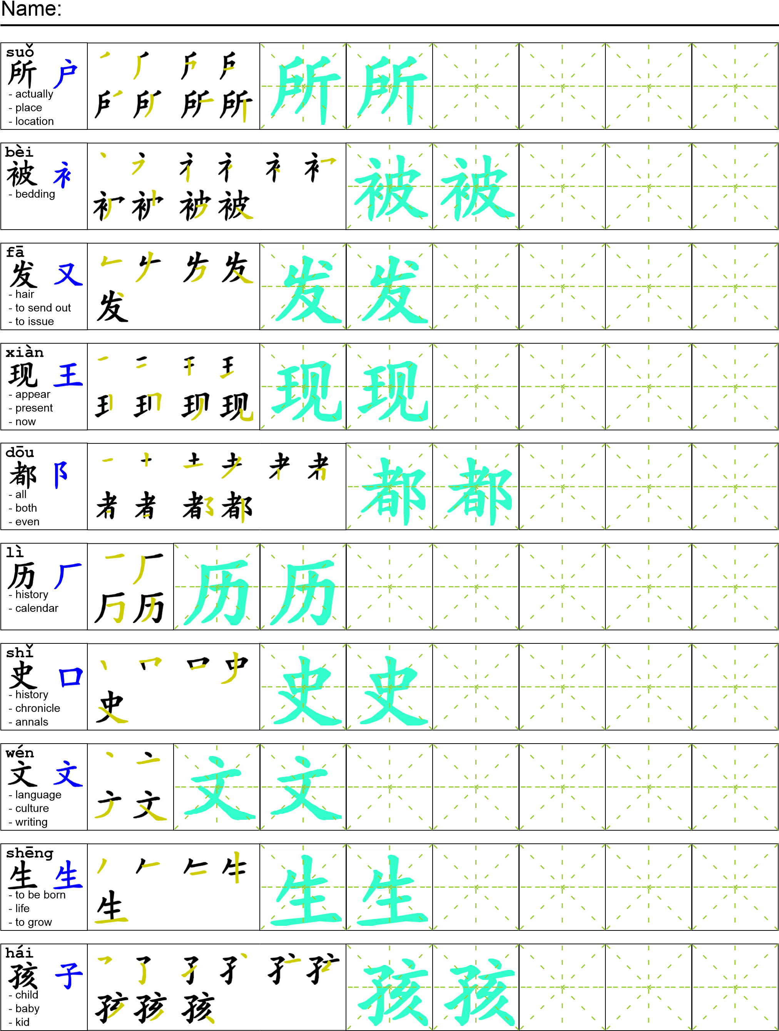
Reading

我们回了家。在家里我记得我们还找到了所有被偷的用品。我和妹妹去看了看被偷的东西。我发现这些书都是小学的书。有数学，历史，文学，地理，还有科学，但是都是给小孩子看的，大学生不用这些书。

Task Completion

Once all tasks are complete turn the assignment in to collect the points for the project.
Task 1: Trace the vocabulary and copy the text into your notebook.

Task 2: Answer Comprehension Questions.

Task 3: Write the Pinyin for the Reading.

Task 4: Translate the Reading into English.

Task 5: Record yourself reading the passage.

Comprehension Questions
- What are the different uses of 了?
- What is the function of 被?
- What subjects do you like? Respond with Chinese characters.
_______________________________________________________________________________

